Instalment #1
Quilt Block Name: Lady of the Lake
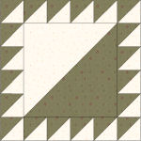
Block Unfinished Size: 12½"
Number of Blocks to Make: Four
Cutting Instructions:
Colour | # to Cut | Size & Shape | Second Cut*
Colour A (Green) | 40 | 2⅞" Squares
Colour A (Green) | 2 | 8⅞" Square
Colour B (Cream) | 40 | 2⅞" Squares
Colour B (Cream) | 2 | 8⅞" Square
* - Cut once diagonally. - Cut twice diagonally.
Sewing Instructions:
(Note: Sewing Instructions are for 1 block. You will need to make 4 identical blocks.)
Step 1: Place a Colour B (cream) 2⅞" triangle on a Colour A (green) triangle, right sides together. Sew along the longest edge using a ¼" seam allowance. Press the seam allowance toward the Colour A (green) fabric and trim points. Make 20. (Each unit should measure 2½".)
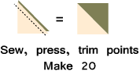
Step 2: Place a Colour B (cream) 8⅞" triangle on a Colour A (green) triangle, right sides together. Sew along the longest edge using a ¼" seam allowance. Press the seam allowance toward the Colour A (green) fabric and trim points. Make 1. (This unit should measure 8½".)
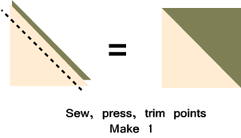
Step 3: Arrange four Step 1 units, as shown below. Sew together using a ¼” seam allowance. Press the seam allowances to one side. Make 2. (Each unit should measure 2½" x 8½".)
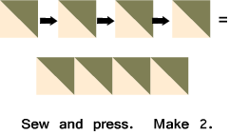
Step 4. Arrange six Step 1 units, as shown below. Sew together using a ¼" seam allowance.
Press the seam allowances to one side. Make 2. (Each unit should measure 2½" x 12½".)
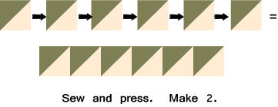
Step 5: Sew a Step 3 unit to the left side of the Step 2 unit. Sew the remaining Step 3 unit to the right side of the Step 2 unit. Press the seam allowances toward the Step 2 unit. Make 1. (This unit should measure 8½" x 12½".)
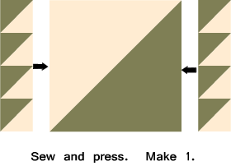
Step 6: Sew a Step 4 unit to the top of the Step 5 unit. Sew the remaining Step 4 unit to the bottom of the Step 5 unit. Press the seam allowances toward the Step 5 unit. Make 1. (Your block will measure 12½" unfinished. It will measure 12" when it is sewn into a quilt.)
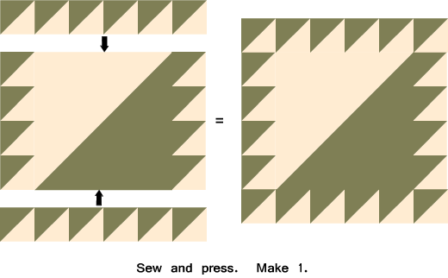

That's it! Don't forget to make three more "Ladies" for a total of FOUR blocks!

