Instalment #11
Component Name: Sashing Strips
Unfinished Size: 3½" x 12½"
Number to Make: Forty
Cutting Instructions:
Colour | # to Cut | Size & Shape | Second Cut*
Colour B (Cream) | 40 | 1½" x 12½" Rectangles
Colour G (Dk Blue) | 80 | 1½" x 12½" Rectangles

Sewing Instructions:
Step 1: Sew a Colour G (dk blue) 1½" x 12½" rectangle to both long sides of a Colour B (cream) 1½" x 12½" rectangle as shown below. Press the seam allowances toward the darker fabric. Make 40. (Each pieced sashing strip will measure 3½" x 12½".)
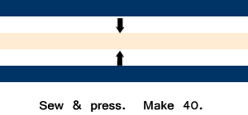

That's all for today! Check back next month for the final block and assembly instructions!

