Instalment #6
Quilt Block Name: Flying X
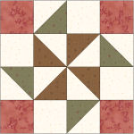
Block Unfinished Size: 12½"
Number of Blocks to Make: One
Cutting Instructions:
Colour | # to Cut | Size & Shape | Second Cut*
Colour A (Green) | 2 | 3⅞" Squares
Colour B (Cream) | 4 | 3½" Squares
Colour B (Cream) | 4 | 3⅞" Squares
Colour C (Red) | 4 | 3½" Squares
Colour D (Brown) | 2 | 3⅞" Squares
* - Cut once diagonally. - Cut twice diagonally.
Sewing Instructions:
(Note: Sewing Instructions are for 1 block.)
Step 1: Sew a Colour A (green) 3⅞" triangle and a Colour B (cream) 3⅞" triangle together as shown below. Press the seam allowances toward the darker fabric and trim points. Make 4. (This unit should measure 3½" x 3½".)
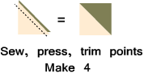
Step 2: Sew a Colour D (brown) 3⅞" triangle and a Colour B (cream) 3⅞" triangle together as shown below. Press the seam allowances toward the darker fabric and trim points. Make 4. (This unit should measure 3½" x 3½".)
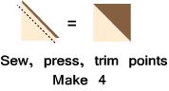
Step 3: Arrange the Step 1 units, the Step 2 units, the Colour B (cream) 3½" squares, and the Colour C (red) squares as shown below. Sew into rows and press the seam allowances for rows 1 and 3 to the right and press the seam allowances for rows 2 and 4 to the left. Next, sew the rows together to finish the block. Press the seam allowances to one side. (Note: to reduce bulk in the middle of the pinwheel, you can press the seam open.) Make 1. (The block will measure 12½" at this point. It will measure 12" when it is sewn into the quilt.)
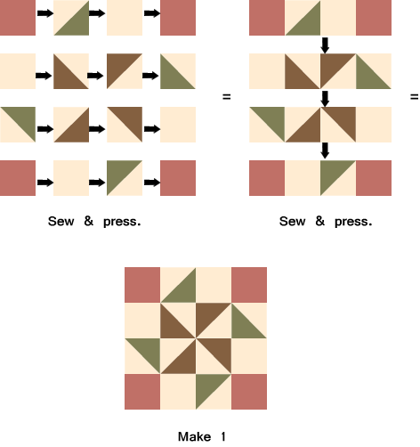

Part 2 - Forty Half-Square Triangles
Cutting Instructions:
Colour | # to Cut | Size & Shape | Second Cut*
Colour F (Dark Cream) | 20 | 6⅞" Squares
Colour G (Dark Blue) | 20 | 6⅞" Squares
* - Cut once diagonally.

Step 4: Sew a Colour G (dk blue) 6⅞" triangle and a Colour F (dk cream) 6⅞" triangle together as shown below. Press the seam allowances toward the darker fabric and trim points. Make 40. (This unit should measure 6½" x 6½".)
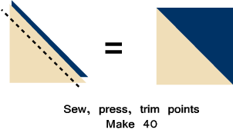
That's all for this month! Save the Part 2 units for later. They will be used in the borders.

