Instalment #8
Quilt Block Name: Susannah
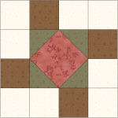
Block Unfinished Size: 12½"
Number of Blocks to Make: One
Cutting Instructions:
Colour | # to Cut | Size & Shape | Second Cut*
Colour A (Green) | 2 | 3⅞" Squares
Colour B (Cream) | 8 | 3½" Squares
Colour C (Red) | 1 | 4¾" Square
Colour D (Brown) | 4 | 3½" Squares
* - Cut once diagonally. - Cut twice diagonally.
Sewing Instructions:
(Note: Sewing Instructions are for 1 block.)
Step 1: Sew a Colour A (green) 3⅞" triangle to the left and right ends of the Colour C (red) 4¾" square as shown below. Press the seam allowances toward the Colour C (red) fabric and trim points. Next, sew a Colour A (green) 3⅞" triangle to the top and bottom of the same Colour C (red) square as shown below. Make 1. (This unit should measure 6½" x 6½".)
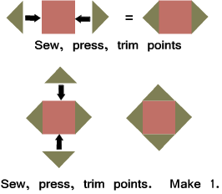
Step 2: Sew a Colour D (brown) 3½" square to a Colour B (cream) 3½" square as shown below. Press the seam allowance toward the darker fabric. Make 2. (This unit should measure 3½" x 6½".)
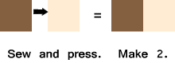
Step 3: Sew a Step 2 unit to the left and right sides of the Step 1 unit as shown below. Press the seam allowances toward the Step 2 units. Make 1. (This unit should measure 6½" x 12½".)
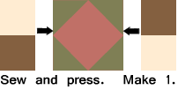
Step 4: Sew three Colour B (cream) 3½" squares and one Colour D (brown) 3½" square as shown below. Press the seam allowances toward the darker fabric. Make 2. (This unit should measure 3½" x 12½".)
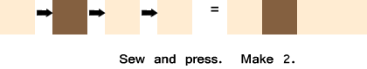
Step 5: Sew a Step 4 unit to the top and bottom of the Step 3 unit as shown below. Press the seam allowances toward the Step 4 units. Make 1. (The block will measure 12½" at this point. It will measure 12" when it is sewn into the quilt.)
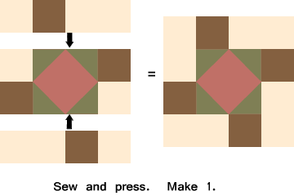

Part 2 - Eight Half Square Triangles
Cutting Instructions:
Colour | # to Cut | Size & Shape | Second Cut*
Colour A (Green) | 4 | 6⅞" Squares
Colour F (Dk Cream) | 4 | 6⅞" Squares
* - Cut once diagonally.
Step 6: Layer a Colour F (dk cream) 6⅞" triangle on a Colour A (green) 6⅞" triangle and sew along the longest edge as shown below. Press the seam allowance toward the darker fabric and trim points. Make 8. (This unit should measure 6½" x 6½".)
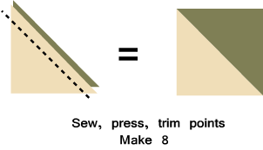
That's all for this month! Save the Part 2 units for later. They will be used in the borders.

