Instalment #3
Quilt Block Name: Ohio Star
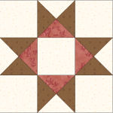
Block Unfinished Size: 12½"
Number of Blocks to Make: One
Cutting Instructions:
Colour | # to Cut | Size & Shape | Second Cut*
Colour B (Cream) | 5 | 4½" Squares
Colour B (Cream) | 1 | 5¼" Square
Colour C (Red) | 1 | 5¼" Square
Colour D (Brown) | 2 | 5¼" Squares
* - Cut once diagonally. - Cut twice diagonally.
Sewing Instructions:
(Note: Sewing Instructions are for 1 block.)
Step 1: Sew a Colour B (cream) 5¼" triangle and a Colour D (brown) 5¼" triangle together as shown below. Press the seam allowance toward the Colour D (brown) fabric and trim points. Make 4.
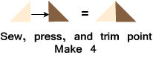
Step 2: Sew a Colour C (red) 5¼" triangle and a Colour D (brown) 5¼" triangle together as shown below. Press the seam allowance toward the Colour D (brown) fabric and trim points. Make 4.
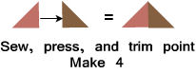

Step 3: Sew a Step 1 and Step 2 unit together as shown below. Press the seam allowances to one side. Make 4. (This unit should measure 4½".)
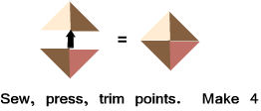
Step 4. Arrange all of the block units as shown below. Sew together to form three rows. Press the seam allowances toward the Colour B (cream) 4½" square. Next, sew the rows together to finish the block. Press the seam allowances away the centre row. (Your block should measure 12½" x 12½".)
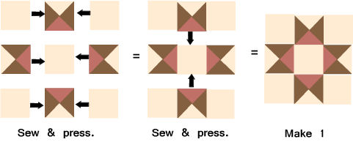
That's it!

