Instalment #10
Quilt Block Name: Ribbon Quilt
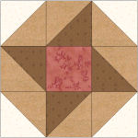
Block Unfinished Size: 12½"
Number of Blocks to Make: One
Cutting Instructions:
Colour | # to Cut | Size & Shape | Second Cut*
Colour B (Cream) | 2 | 4⅞" Squares
Colour C (Red) | 1 | 4½" Square
Colour D (Brown) | 2 | 4⅞" Squares
Colour E (Tan) | 4 | 4⅞" Squares
* - Cut once diagonally. - Cut twice diagonally.
Sewing Instructions:
(Note: Sewing Instructions are for 1 block.)
Step 1: Sew a Colour B (cream) 4⅞" triangle and a Colour E (tan) 4⅞" triangle together as shown below. Press the seam allowances toward the darker fabric and trim points. Make 4. (This unit will measure 4½" x 4½".)
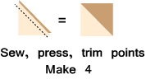
Step 2: Sew a Colour E (tan) 4⅞" triangle and a Colour D (brown) 4⅞" triangle together as shown below. Press the seam allowances toward the darker fabric and trim points. Make 4. (This unit will measure 4½" x 4½".)
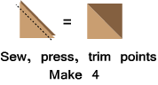
Step 3: Arrange the Step 1 units, the Step 2 units, and the Colour C (red) 4½" square, as shown below. Sew together to form three rows. Press the seam allowances toward the Step 2 units. Next, sew the rows together to finish the block. Press the seam allowances toward the centre row. (Your block should measure 12½" x 12½".)
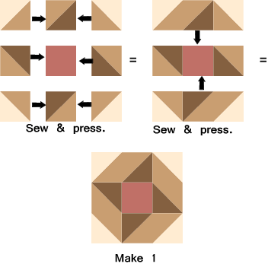
That's all for this month!

