Instalment #7
Quilt Block Name: Swamp Angel
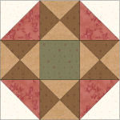
Block Unfinished Size: 12½"
Number of Blocks to Make: One
Cutting Instructions:
Colour | # to Cut | Size & Shape | Second Cut*
Colour A (Green) | 1 | 4½" Square
Colour B (Cream) | 2 | 4⅞" Squares
Colour C (Red) | 2 | 4⅞" Squares
Colour D (Brown) | 2 | 5¼" Squares
Colour E (Tan) | 2 | 5¼" Squares
* - Cut once diagonally. - Cut twice diagonally.
Sewing Instructions:
(Note: Sewing Instructions are for 1 block.)
Step 1: Sew a Colour C (red) 4⅞" triangle and a Colour B (cream) 4⅞" triangle together as shown below. Press the seam allowances toward the darker fabric and trim points. Make 4. (This unit should measure 4½" x 4½".)
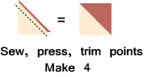
Step 2: Sew a Colour E (tan) 5¼" triangle and a Colour D (brown) 5¼" triangle together as shown below. Press the seam allowances toward the darker fabric and trim point. Make 8.
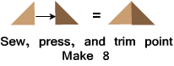
Step 3: Sew two Step 2 units together as shown below. Press the seam allowances to one side and trim points. Make 4. (This unit should measure 4½" x 4½".)
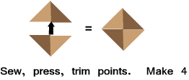
Step 4: Arrange the Step 1 units, the Step 3 units, and the Colour A (green) square as shown below. Sew into rows and press the seam allowances away from the Step 3 units. Next, sew the rows together to finish the block. Press the seam allowances away from the centre. Make 1. (The block will measure 12½" at this point. It will measure 12" when it is sewn into the quilt.)
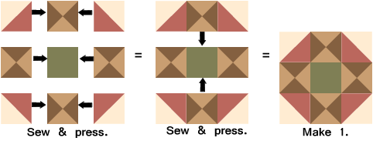

Part 2 - Four Nine-Patch Blocks
Cutting Instructions:
Colour | # to Cut | Size & Shape | Second Cut*
Colour A (Green) | 16 | 2½" Squares
Colour B (Cream) | 20 | 2½" Squares
* - Cut once diagonally.
Step 5: Arrange four Colour A (green) 2½" squares and five Colour B (cream) 2½" squares, as shown below. Sew into rows and press seam allowances toward the darker squares. Next, sew the rows together to finish the nine-patch unit. Press the seam allowances toward the centre row. Make 4. (This unit should measure 6½" x 6½".)
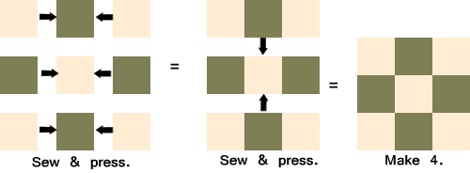
That's all for this month! Save the Part 2 units for later. They will be used in the borders.

