Instalment #9 - Part 1
Quilt Block Name: Capital T
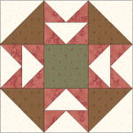
Block Unfinished Size: 12½"
Number of Blocks to Make: One
Cutting Instructions:
Colour | # to Cut | Size & Shape | Second Cut*
Colour A (Green) | 1 | 4½" Square
Colour B (Cream) | 2 | 4⅞" Squares
Colour B (Cream) | 2 | 5¼" Squares
Colour C (Red) | 8 | 2⅞" Squares
Colour D (Brown) | 2 | 4⅞" Squares
* - Cut once diagonally. - Cut twice diagonally.
Sewing Instructions:
(Note: Sewing Instructions are for 1 block.)
Step 1: Sew a Colour B (cream) 4⅞" triangle and a Colour D (brown) 4⅞" triangle together as shown below. Press the seam allowances toward the darker fabric and trim points. Make 4. (This unit will measure 4½" x 4½".)
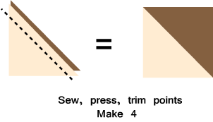
Step 2: Sew a Colour C (red) 2⅞" triangle to the right side of a Colour B (cream) 5¼" triangle as shown below. Press the seam allowances toward the darker fabric and trim points. Repeat on the left side. Make 8. (This unit will measure 2½" x 4½".)
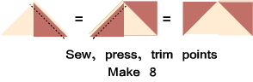
Step 3: Arrange two Step 2 units as shown below. Sew together and press the seam allowance towards the top Step 2 unit. Make 4. (This unit will measure 4½" x 4½".)
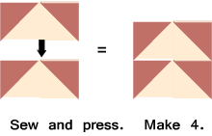
Step 4: Arrange the Step 1 units, the Step 3 units, and the Colour A (green) 4½" square, as shown below. Sew together to form three rows. Press the seam allowances away from the Step 3 units. Next, sew the rows together to finish the block. Press the seam allowances open. (Your block should measure 12½" x 12½".)
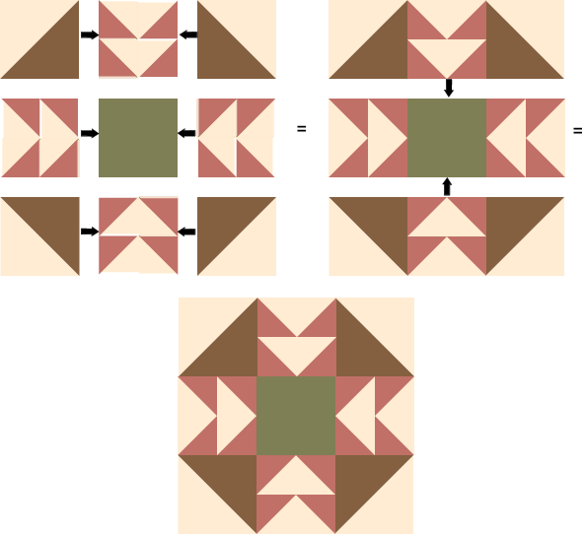

Part 2- Twenty-Five Nine Patch Blocks
Cutting Instructions:
Colour | # to Cut | Size & Shape | Second Cut*
Colour B (Cream) | 125 | 1½" Squares
Colour G (Dark Blue) | 100 | 1½" Squares
* - Cut once diagonally. - Cut twice diagonally.
Step 5: Arrange five Colour B (cream) 1½" squares and four Colour G (dk blue) 1½" squares as shown below. Sew together to form three rows. Press the seam allowances toward the Colour G (dk blue) squares. Next, sew the rows together to finish the Nine Patch block. Press the seam allowance toward the centre row. Make 25. (This block will measure 3½" x 3½".)
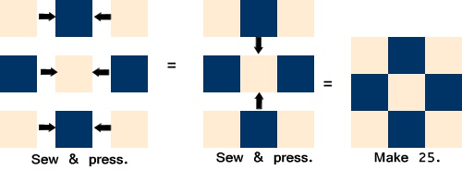
That's all for this month! Save the Part 2 units for later. They will be used in the borders.

