Instalment #2
Quilt Block Name: Road to California
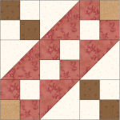
Block Unfinished Size: 12½"
Number of Blocks to Make: Four
Cutting Instructions:
Colour | # to Cut | Size & Shape | Second Cut*
Colour B (Cream) | 32 | 2½" Squares
Colour B (Cream) | 8 | 4⅞" Squares
Colour C (Red) | 24 | 2½" Squares
Colour C (Red) | 8 | 4⅞" Squares
Colour D (Brown) | 16 | 2½" Squares
Colour E (Tan) | 8 | 2½" Squares
* - Cut once diagonally. - Cut twice diagonally.
Sewing Instructions:
(Note: Sewing Instructions are for 1 block. You will need to make 4 identical blocks.)
Step 1: Place a Colour B (cream) 4⅞" triangle on a Colour C (red) triangle, right sides together. Sew along the longest edge using a ¼" seam allowance. Press the seam allowance toward the Colour C (red) fabric and trim points. Make 4. (Each unit should measure 4½".)
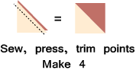
Step 2: Using two Colour B (cream) 2½" squares and two Colour C (red) 2½" squares, sew together as shown below. Press the seam allowances toward the darker fabric. Next, sew the rows together as shown. Press the seam allowance to one side to finish the Colour B/C four patch unit. Make 1. (This unit should measure 4½".)
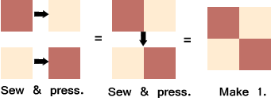
Step 3: Using two Colour B (cream) 2½" squares and two Colour D (brown) 2½" squares, sew together as shown below. Press the seam allowances toward the darker fabric. Next, sew the rows together as shown. Press the seam allowance to one side to finish the Colour B/D four patch unit. Make 2. (This unit should measure 4½".)
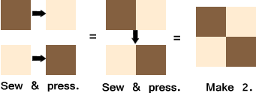
Step 4. Using one Colour B (cream) 2½" square, two Colour C (red) 2½" squares, and one Colour E (tan) 2½", sew together as shown below. Press the seam allowances toward the darker fabric. Next, sew the rows together as shown. Press the seam allowance to one side to finish the Colour B/C/D four patch unit. Make 2. (This unit should measure 4½".)
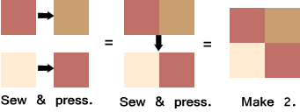
Step 5: Arrange all of the block units as shown below. Sew together to form three rows. Press the seam allowances toward the four patch units. Next, sew the rows together to finish the block. Press the seam allowances toward the centre row. (Your block should measure 12½" x 12½".)
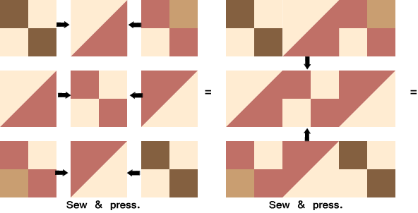
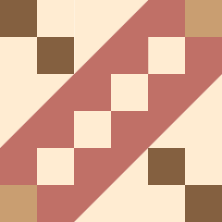
That's it! Don't forget to make three more "Road to California" blocks for a total of FOUR blocks!

