Instalment #4 - Part 1
Quilt Block Name: Girl's Favourite
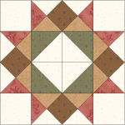
Block Unfinished Size: 12½"
Number of Blocks to Make: One
Cutting Instructions:
Colour | # to Cut | Size & Shape | Second Cut*
Colour A (Green) | 2 | 3⅞" Squares
Colour B (Cream) | 4 | 3½" Squares
Colour B (Cream) | 2 | 4¼" Squares
Colour B (Cream) | 2 | 3⅞" Squares
Colour C (Red) | 2 | 4¼" Squares
Colour D (Brown) | 4 | 2⅝" Squares
Colour E (Tan) | 2 | 4¼" Squares
* - Cut once diagonally. - Cut twice diagonally.
Sewing Instructions:
(Note: Sewing Instructions are for 1 block.)
Step 1: Sew a Colour C (red) 4¼" triangle and a Colour E (tan) 4¼" triangle together as shown below. Press the seam allowance toward the Colour E (tan) fabric and trim points. Make 4.
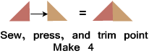
Step 2: Sew a Colour E (tan) 4¼" triangle and a Colour C (red) 4¼" triangle together as shown below. Press the seam allowance toward the Colour E (tan) fabric and trim points. Make 4.
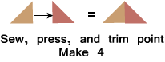
Step 3: Sew two Colour B (cream) 4¼" triangles to a Colour D (brown) 2-5/8" square as shown below. Press the seam allowances away from the Colour D square and trim points. Make 4.
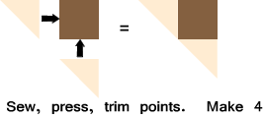
Step 4: Sew a Step 1 and Step 2 unit to a Step 3 unit as shown below. Press the seam allowances toward the Step 3 unit and trim points. Make 4. (This unit should measure 3½" x 6½".)
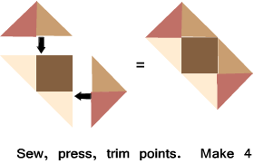
Step 5: Sew a Colour A (green) 3⅞" triangle and a Colour B 3⅞" triangle together as shown below. Press the seam allowances toward the darker fabric and trim points. Make 4. (This unit should measure 3½" x 3½".)
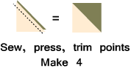
Step 6: Arrange the Step 5 units as shown below. Sew into 2 rows and press the seam allowances in opposite directions. Sew the rows together to finish the unit. Press the seam allowances to one side. (This unit should measure 6½" x 6½".)
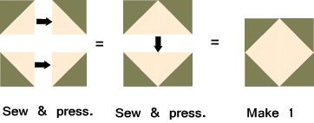
Step 7: Arrange the Step 4 units, Step 6 unit, and the four Colour B (cream) 3½” squares as shown below. Sew together to form three rows. Press the seam allowances for the top and bottom rows toward the Colour B (cream) 3½" squares. Press the seam allowance for the middle row toward the Step 6 unit. Next, sew the rows together to finish the block. Press the seam allowances toward the centre row. (Your block should measure 12½" x 12½".)
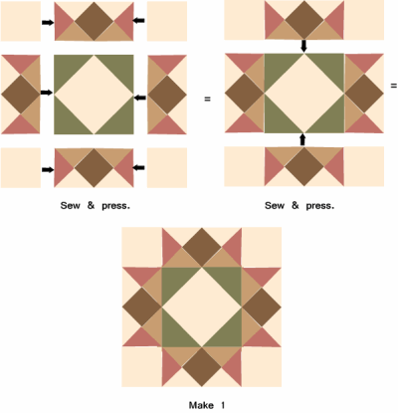
Part 2 - Four Nine Patch Blocks
Cutting Instructions:
Colour | # to Cut | Size & Shape | Second Cut*
Colour B (Cream) | 20 | 1½" Squares
Colour C (Red) | 16 | 1½" Squares
Step 8: Arrange five Colour B (cream) 1½" squares and four Colour C (red) 1½" squares as shown below. Sew together to form three rows. Press the seam allowances toward the Colour C (red) squares. Next, sew the rows together to finish the Nine Patch block. Press the seam allowance toward the centre row. Make 4. (This unit will measure 3½" x 3½".)
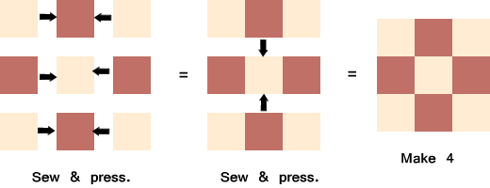

Part 3- Eight Half-Square Triangles
Cutting Instructions:
Colour | # to Cut | Size & Shape | Second Cut*
Colour B (Cream) | 4 | 3⅞" Squares
Colour D (Brown) | 4 | 3⅞" Squares
* - Cut once diagonally. - Cut twice diagonally.
Step 9: Sew a Colour B (cream) 3⅞" triangle and a Colour D (brown) 3⅞" triangle together as shown below. Press the seam allowances toward the darker fabric and trim points. Make 8. (This unit will measure 3½" x 3½".)
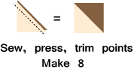
That's all for this month! Save the Part 2 and Part 3 units for later. They will be used in the borders.

