Instalment #5 - Part 1
Quilt Block Name: Clay's Choice
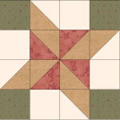
Block Unfinished Size: 12½"
Number of Blocks to Make: One
Cutting Instructions:
Colour | # to Cut | Size & Shape | Second Cut*
Colour A (Green) | 4 | 3½" Squares
Colour B (Cream) | 4 | 3½" Squares
Colour B (Cream) | 2 | 3⅞" Squares
Colour C (Red) | 2 | 3⅞" Squares
Colour E (Tan) | 4 | 3⅞" Squares
* - Cut once diagonally. - Cut twice diagonally.
Sewing Instructions:
(Note: Sewing Instructions are for 1 block.)
Step 1: Sew a Colour B (cream) 3⅞" triangle and a Colour E (tan) 3⅞" triangle together as shown below. Press the seam allowances toward the darker fabric and trim points. Make 4. (This unit will measure 3½" x 3½".)
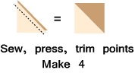
Step 2: Sew a Colour B (cream) 3⅞" triangle and a Colour C (red) 3⅞" triangle together as shown below. Press the seam allowances toward the darker fabric and trim points. Make 4. (This unit will measure 3½" x 3½".)
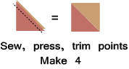
Step 3: Arrange the Step 1 units, the Step 2 units, the four Colour A (green) 3½" squares, and the four Colour B (cream) 3½” squares as shown below. Sew together to form four rows. Press the seam allowances for the first and third rows to the left and press the seam allowances for the second and fourth rows toward the right. Next, sew the rows together to finish the block. Press the seam allowances toward the top and bottom rows and press the seam allowance for the second and third rows open. (Your block should measure 12½" x 12½".)
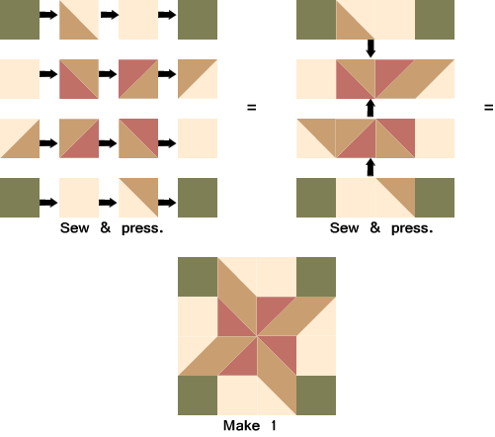

Part 2- Thirty-Six Half-Square Triangles
Cutting Instructions:
Colour | # to Cut | Size & Shape | Second Cut*
Colour B (Cream) | 18 | 3⅞" Squares
Colour G (Dark Blue) | 18 | 3⅞" Squares
* - Cut once diagonally. - Cut twice diagonally.
Step 4: Sew a Colour B (cream) 3⅞" triangle and a Colour G (dk blue) 3⅞" triangle together as shown below. Press the seam allowances toward the darker fabric and trim points. Make 36. (This unit will measure 3½" x 3½".)
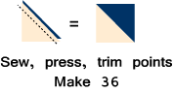
That's all for this month! Save the Part 2 units for later. They will be used in the borders.

