Instalment #12
PART 1: Block Name: Nine Patch
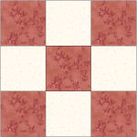
Unfinished Size: 3½" x 3½"
Number to Make: Four
Cutting Instructions:
Colour | # to Cut | Size & Shape | Second Cut*
Colour B (Cream) | 16 | 1½" x 1½" squares
Colour C (Red) | 20 | 1½" x 1½" Squares
Sewing Instructions:
Step 1: Using the image below as your guide, arrange four Colour B (cream) and five Colour C (red) 1½" x 1½" squares. Sew the squares into three rows and press the seam allowances toward the darker fabric. Next, sew the rows together to finish the block. Press the seam allowances away from the centre row. Make 4. (Each Nine Patch block will measure 3½" x 3½".)
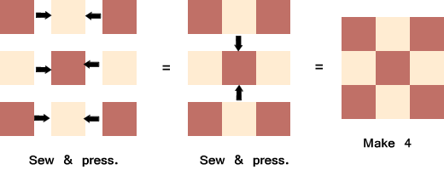

PART 2: Block Name: Half-Square Triangle
Unfinished Size: 3½" x 3½"
Number to Make: Eight
Cutting Instructions:
Colour | # to Cut | Size & Shape | Second Cut*
Colour E (Tan) | 4 | 3⅞" squares
Colour G (Dark Blue) | 4 | 3⅞" Squares
* - Cut once diagonally. - Cut twice diagonally.
Sewing Instructions:
Step 2: Layer a Colour E (tan) 3⅞" triangle on a Colour G (dk blue) 3⅞" triangle as shown below. Sew along the longest edge. Press the seam allowance toward the darker fabric and trim points. Make 8. (Each Half-Square Triangle will measure 3½" x 3½".)
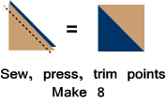

Part 3 - Block Name: Half-Square Triangle
Note: The patches used in this part may not have been included in the total quilt cutting chart. I just realized that more of these Half-Square Triangles are needed to complete one of the borders for the quilt. Since I included extra inches for each fabric in the yardage chart, you should have enough fabric to make this unit.
Cutting Instructions:
Colour | # to Cut | Size & Shape | Second Cut*
Colour B (Cream) | 18 | 3⅞" Squares
Colour G (Dark Blue) | 18 | 3⅞" Squares
* - Cut once diagonally. - Cut twice diagonally.
Step 3: Sew a Colour B (cream) 3⅞" triangle and a Colour G (dk blue) 3⅞" triangle together as shown below. Press the seam allowances toward the darker fabric and trim points. Make 36. (This unit will measure 3½" x 3½".)
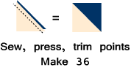

PART 4: Assemble the Blocks, Sashing Strips, and Cornerstones
Sewing Instructions:
Note: For this part, you will need all of the 12½" (unfinished size) blocks that you've made plus the twenty-five 3½" (unfinished size) Nine Patch blocks from Instalment 9 and the Sashing Strips from Instalment 11.
Step 4: Arrange five 3½" (unfinished size) Nine Patch blocks from Instalment 9 and four Sashing Strips from Instalment 11 as shown below. Sew together to form a row and press the seam allowances toward the sashing strips. Make 5.
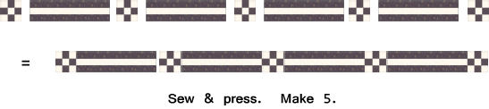
Step 5: Arrange five Sashing Strips from Instalment 11, two Lady of the Lake blocks, the Ohio Star block, and the Girl's Favourite block as shown below. Sew together to form a row and press the seam allowances toward the sashing strips. Make 1.
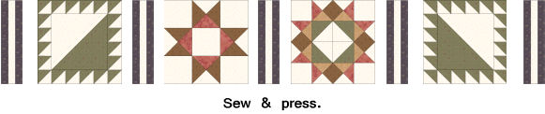
Step 6: Arrange five Sashing Strips from Instalment 11, the Clay's Choice block, two Road to California blocks, and the Flying X block as shown below. Sew together to form a row and press the seam allowances toward the sashing strips. Make 1.
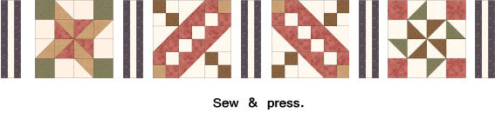

Step 7: Arrange five Sashing Strips from Instalment 11, the Swamp Angel block, two Road to California blocks, and the Susannah block as shown below. Sew together to form a row and press the seam allowances toward the sashing strips. Make 1.
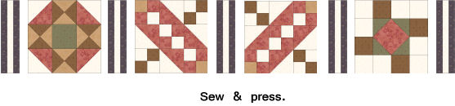
Step 8: Arrange five Sashing Strips from Instalment 11, the Capital T block, two Road to California blocks, and the Ribbon Quilt block as shown below. Sew together to form a row and press the seam allowances toward the sashing strips. Make 1.
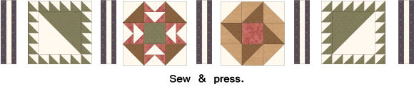
Step 9: Sew the block rows together with a Step 3 row above and below each one so that your quilt centre looks like this:
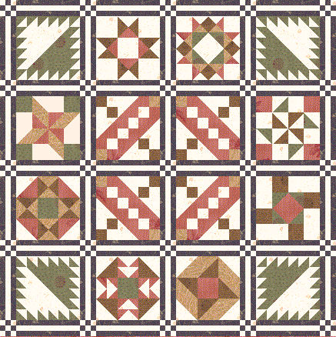

PART 5: First Border
Cutting Instructions:
Colour | # to Cut | Size & Shape | Second Cut*
Colour C (Red) | 4 | 2" x 42½" strips
Colour C (Red) | 4 | 2" x 21½" strips
Colour G (Dark Blue) | 4 | 2" Squares
Sewing Instructions:
Step 10: Sew a Colour C (red) 2" x 21½" strip and a Colour C (red) 2" x 42½" strip together along one short side. Press the seam allowance to one side. The strip should now measure 2" x 63½". Make 4 Colour C (red) strips.
Step 11: Sew a Colour G (dk blue) 2" square to each end of a Step 10 Colour C (red) strip. The strip should now measure 2" x 66½". Make 2.
Step 12: Sew a Step 10 Colour C (red) strip to the left and right sides of the quilt centre. Press the seam allowances toward the Step 9 strips. Next, Sew a Step 11 strip to the top and bottom of the quilt centre. Press the seam allowances toward the Step 10 strips.
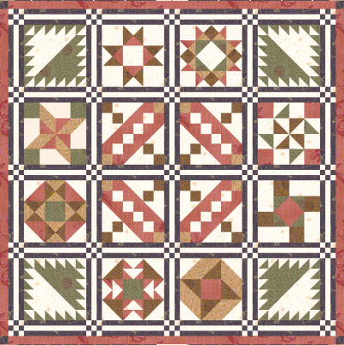

PART 6: Second Border
Note: For this part, you will need the thirty-six 3½" Half-Square Triangles (instructions given with Block 5), the eight 3½" half-square triangles (instructions given with Block 4), the eight 3½" Half-Square Triangles (instructions given with Block 12), the thirty-six 3½" Half-Square Triangles (instructions given with Block 12), and the four 3½" Nine-Patch blocks (instructions given with Block 12).
Sewing Instructions:
Step 13: Using the 3½" Half-Square Triangles, sew two 3½" half-square triangles together as shown below. Press the seam allowance to one side. Make 64. (This unit will measure 3½” x 6½”) (Note: you will have eight half-square triangles left over for the next step.)
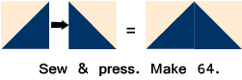

Step 14: Using four of the 3½" Half-Square Triangles and four of the 3½" Half-Square triangles, sew two 3½" half-square triangles together as shown below. Press the seam allowance to one side. Make 4. (This unit will measure 3½" x 6½".)
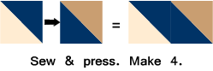
Step 15: Using the remaining 3½" Half-Square Triangles and the four 3½" Half-Square triangles, sew two 3½" half-square triangles together as shown below. Press the seam allowance to one side. Make 4. (This unit will measure 3½" x 6½".)
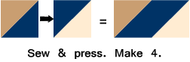
Step 16: Using the 3½" Half-Square Triangles, sew two 3½" half-square triangles together as shown below. Press the seam allowance to one side. Make 4. (This unit will measure 3½" x 6½".)
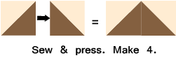
Step 17: Arrange eight Step 13 units, one Step 14 unit , one Step 15 unit, and one Step 16 unit as shown below and sew together to form the Second Border. Make 4.
Next, add a 3½" Nine Patch block to the left and right ends of TWO of the border strips you completed above.
Step 18: Sew the shorter Step 17 border strips to the left and right sides of the quilt centre. Press the seam allowances toward the First Border. Next, sew the longer Step 17 border strips to the top and bottom of the quilt centre. Press the seam allowances toward the First Border.
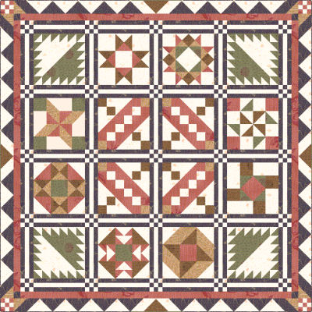

PART 7: Third Border
Note: For this part, you will need the forty 6½" Half-Square Triangles (instructions given with Block 6), the eight 6½" Half-Square Triangles (instructions given with Block 8), and the four 6½" Nine Patch blocks (instructions given with Block 7).
Sewing Instructions:
Step 19: Using the 6½" Half-Square Triangles, sew them together as follows:
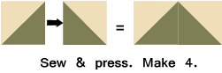
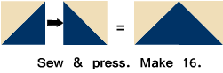
Note: There are eight 6½" Half-Square triangles left over.
Step 20: Arrange the Step 19 units and two of the 6½" Half-Square Triangles as shown below. Sew together to form the Third Border. Press seam allowances to one side. Make 4.

Step 21: Add a 6½" Nine Patch block to each end of a Step 20 border. Press the seam allowances away from the Nine Patch blocks. Make 2.
Step 22: Sew a Step 20 border strip to the left and right sides of the quilt centre. Press the seam allowances toward the Third Border. Next, sew the Step 21 border strips to the top and bottom of the quilt centre. Press the seam allowances toward the Third Border.
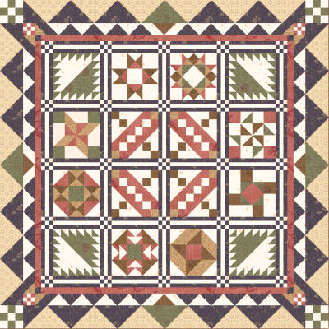

PART 8: Fourth Border
Cutting Instructions:
Colour | # to Cut | Size & Shape | Second Cut*
Colour D (Brown) | 8 | 3½" x 42½" strips
Sewing Instructions:
Step 23: Sew two Colour D (brown) 3½" x 42½" strips together along one short side. Press the seam allowance to one side. Make 4. (This strip should measure 3½" x 84½".)
Step 24: Sew a 3½" Nine Patch block to each end of a Step 23 border strip. Press the seam allowance toward the Step 23 border strip. Make 2.
Step 25: Sew a Step 23 border strip to the left and right sides of the quilt centre. Press the seam allowances toward the Fourth Border. Next, sew the Step 24 border strips to the top and bottom of the quilt centre. Press the seam allowances toward the Fourth Border.
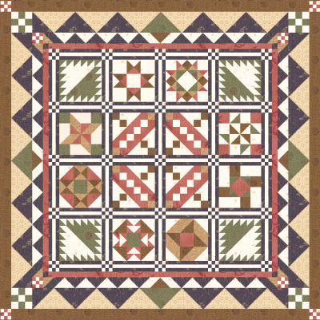

PART 9: Binding
Cutting Instructions:
Colour | # to Cut | Size & Shape | Second Cut*
Colour D (Brown) | 9 | 2½" x width of fabric strips
Sewing Instructions:
Step 26: Sew all of the Colour D (brown) 2½" x width of fabric strips together end to end. Next, fold the binding strip in half so that it measures 1¼" in width. Press the entire strip. Sew the binding to the front of the quilt, raw edges together and mitreing the corners. Finally, fold the binding over the raw edge of the quilt and whip stitch in place on the back of the quilt.
Your quilt is done!! Congratulations.

